|  |  |  |  |  |  |
| --- | --- | --- | --- | --- | --- |
| Variable Name | Test Type | Test Data | Purpose of Data | User’s Expected Result | Actual Result |
| choice[0] | string | y, Y | To continue program | Clears the screen and continues the program. If wrong input is inputted exits the program. Otherwise returns 0 and exits the program. | Clears the screen and continues the program. If wrong input is inputted exits the program. Otherwise returns 0 and exits the program. |

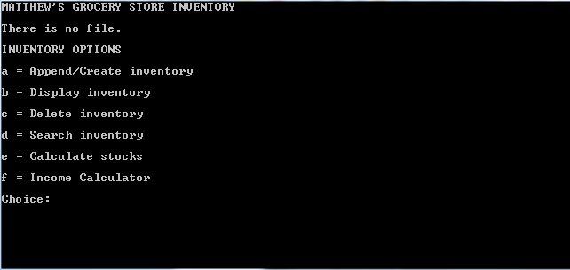

Prompting user to input choice (either “a” “b” “c” “d” “e” or “f” ).

This is also the screen after inputting ‘y’ or ‘Y’ to continue in choice[0].

|  |  |  |  |  |  |
| --- | --- | --- | --- | --- | --- |
| Variable Name | Test Type | Test Data | Purpose of Data | User’s Expected Result | Actual Result |
| choice[0] | string | a | To append data to inventory | The program prompts the user to input data to append into the file. | The program prompts the user to input data to append into the file. |
| append.barcode | string | MGSI0000 | To store product barcode | The product stores the barcode number and asks to input name and price or exits the program if wrong input is provided. | The product stores the barcode number and asks to input name and price or exits the program if wrong input is provided. |
| append.label | string | Pepsi 2L | To store product name | The program stores the product name. | The program stores the product name. |
| append.price | float | 356.65 | To store product price | The program stores the price information or exits the program if wrong input is provided. | The program stores the price information or exits the program if wrong input is provided. |

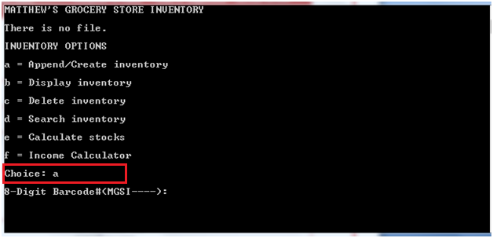

Prompting user to enter information to be appended.

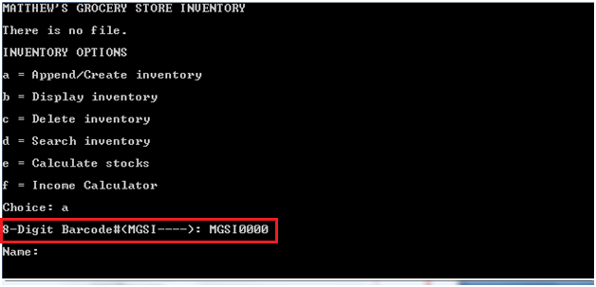

Stores the product barcode in the input buffer.

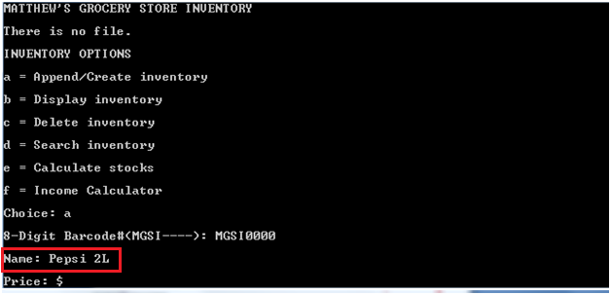

Stores the product name in the input buffer.

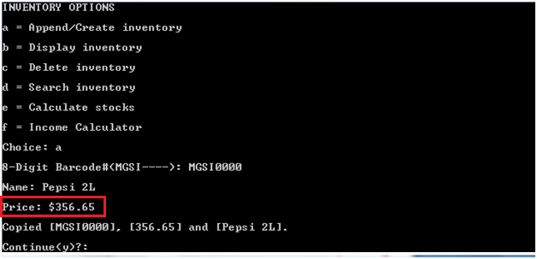

Stores the product price in the input buffer.

Also saves the product barcode, name and price in file and provides feedback.

Asks the user if he/she wants to continue the program.

|  |  |  |  |  |  |
| --- | --- | --- | --- | --- | --- |
| Variable Name | Test Type | Test Data | Purpose of Data | User’s Expected Result | Actual Result |
| choice[0] | string | b | To display inventory data | The program either displays that there is no file or displays the inventory. | The program either displays that there is no file or displays the inventory. |

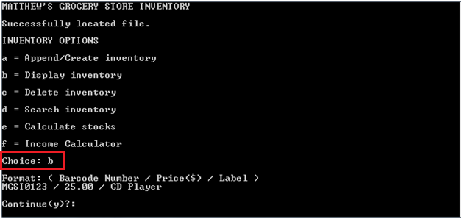

Display of inventory and prompts user to continue the program.

|  |  |  |  |  |  |
| --- | --- | --- | --- | --- | --- |
| Variable Name | Test Type | Test Data | Purpose of Data | User’s Expected Result | Actual Result |
| choice[0] | string | c | To delete the inventory | The program deletes the inventory files database.dat and price.dat and provides feedback. | The program deletes the inventory files database.dat and price.dat and provides feedback. |

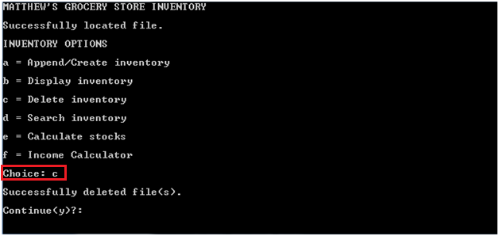

Shows feedback that files are deleted.

|  |  |  |  |  |  |
| --- | --- | --- | --- | --- | --- |
| Variable Name | Test Type | Test Data | Purpose of Data | User’s Expected Result | Actual Result |
| choice[0] | string | d | To search for a record in the inventory | The program prompts the user to input the barcode number of the record to be searched for. | The program prompts the user to input the barcode number of the record to be searched for |
| search.barcode | string | MGSI0000 | To search for product record | The program searches inventory for record and displays it. If not found or wrong input, provides feedback. | The program searches inventory for record and displays it. If not found or wrong input, provides feedback. |

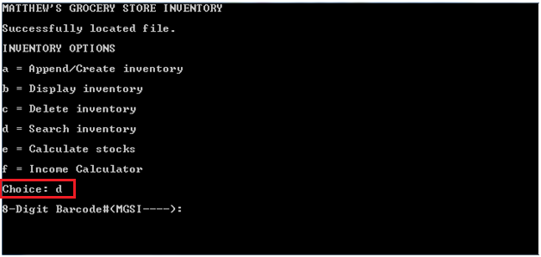

Prompts the user to input the barcode of product to search for.

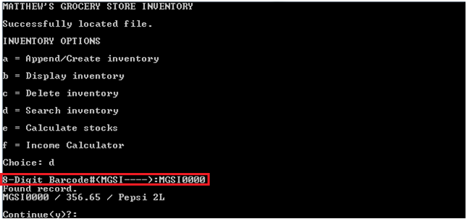

Searches the inventory for record using barcode # and outputs the found record data.

|  |  |  |  |  |  |
| --- | --- | --- | --- | --- | --- |
| Variable Name | Test Type | Test Data | Purpose of Data | User’s Expected Result | Actual Result |
| choice[0] | string | e | To calculate the overall stock and budget information | The program prompts the user to input stock information (i.e. Current Budget). | The program prompts the user to input stock information (i.e. Current Budget). |
| budget | float | 2000 | To store budget value to calculate stocks | The program stores the budget price. If characters are inputted, exits the program. | The program stores the budget price. If characters are inputted, exits the program. |
| income | float | 400 | To store total income value to calculate stocks | The program stores the total income value and calculates stock information. | The program stores the total income value and calculates stock information. |

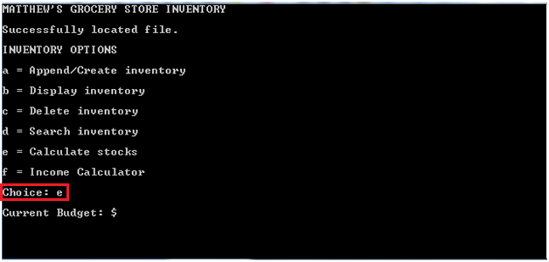

Prompts user to input stock information.

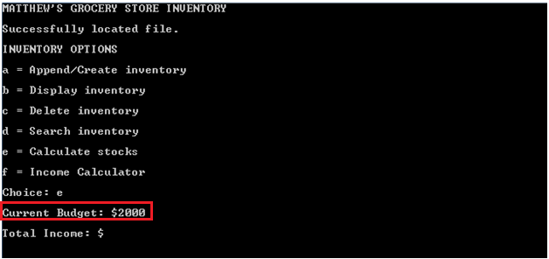

Stores the budget value in the input buffer.

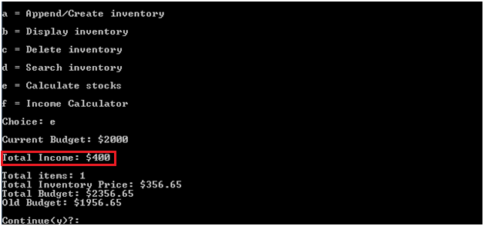

Stores the total income in the input buffer.

Calculates and displays stock information.

|  |  |  |  |  |  |
| --- | --- | --- | --- | --- | --- |
| Variable Name | Test Type | Test Data | Purpose of Data | User’s Expected Result | Actual Result |
| choice[0] | string | f | To calculate the overall income | The program prompts the user to input income values sequentially. | The program prompts the user to input income values sequentially. |
| itemssold | integer | 2 | To store item number to calculate total income | Stores the number of items. If number of items are 0 or characters, exits the program. | Stores the number of items. If number of items are 0 or characters, exits the program. |
| current_price | float | 250, 150 | To store prices of items to calculate total income. | Stores the income values and displays the total income. If a character or 0 income is inputted, exits the program. | Stores the income values and displays the total income. If a character or 0 income is inputted, exits the program. |

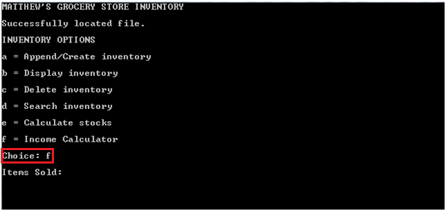

Prompts user to input income information.

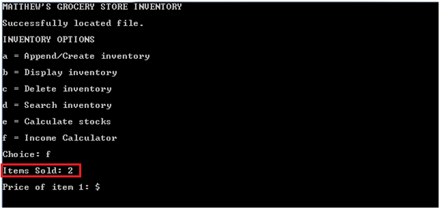

Stores the number of items in the input buffer.

Prompts the user to enter the prices of items sequentially.

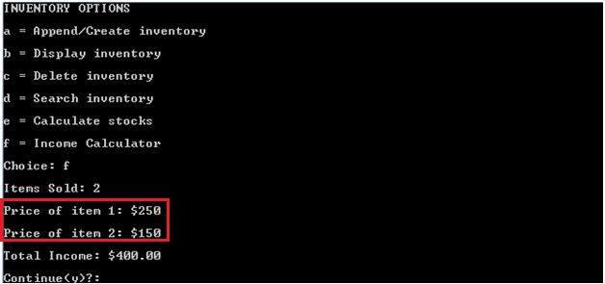

Stores the income values in the input buffer.

Calculates and displays the total income.

Prompts the user to continue.